Section 1: Idea
IV Tracer: In general, an I-V tracer is made of a power conditioner, used to force the PV generator in a specific DC operating point, and a data acquisition system, to sense the resulting PV current and voltage and convert them into digital data.
Proposed Solution: the proposed I-V tracer is based on a double-leg linear circuit employing Darlington transistors and resistive load, allowing for the acquisition of the operating points in static conditions. The device embeds a novel active disconnecting circuit composed of a power MOSFET transistor, and a bypass diode to bypass the string current during the I-V curve measurement. Additionally, a proposed control algorithm is implemented to evenly distribute the measured points along the I-V curve, thus guaranteeing a sweeping time less than 1 s. The developed I-V tracer is tested and validated on a set of PV modules concerning different technologies under different levels of irradiance and environmental conditions.
Section 2: Materials and Methods
A simple PV generator, such as a single solar cell, can be modelled according to the single diode model [23], described by the following equation:
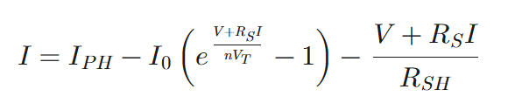
The PV of a single cell can be used to find the equivalent current draw to the bias resistor and, using it a value (minimal percentage) above the required threshold can be employed to ensure proper bias resistance.
I – output current delivered by the PV cell/module
V – output voltage across the PV cell/module
I_PH – photo-generated current (current produced by light)
R_S – series resistance (models internal resistive losses in the cell)
R_SH – shunt resistance (models leakage paths across the p–n junction)
n – diode ideality factor (describes how closely the diode follows the ideal diode equation)
V_T – thermal voltage (= kT/q), sets temperature dependence of the diode behavior
I₀ – diode saturation current (reverse-bias leakage current of the diode)

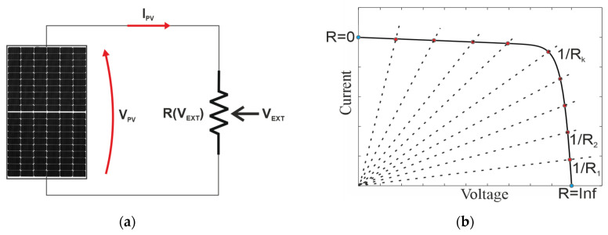
Figure 1: Single PV Cell Configuration

This is the principle operation of an IV Curve tracer, a variable load, like the variable voltage delivered by the PV cell (a)). In b), the sweeping of the operating points in red along hte characteristic Current and Voltage, are calculated to determine the most efficient distribution of current and voltage to meet power draw requirements.

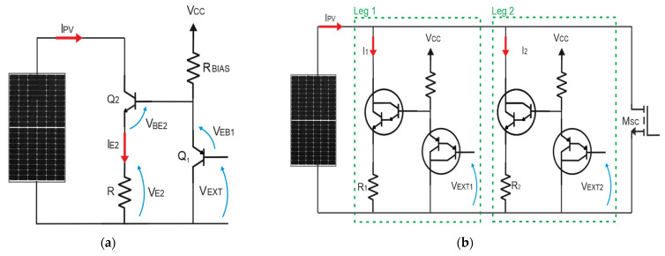
NPN
NPN
PNP
PNP
NPN
PNP
Figure 2: Our implement circuit.

PV Model / Electrical Quantities
- IPV – PV module output current
- V / VPV – PV module voltage
- ISC – short-circuit current of the PV module
- MPP – maximum power point
- IE2 – emitter current of Q2 (≈ IPV)

Transistor Junction Voltages
- VEXT – external control voltage applied to Q1 (controls load)
- VEB1 – emitter–base voltage of Q1 (PNP)
- VBE2 – base–emitter voltage of Q2 (NPN)
- VE2 – voltage at emitter of Q2 (across load R)
- VCE,sat – saturation voltage of the transistor (limits minimum measurable PV voltage)

Resistances
- R – load resistor in the single-leg circuit
- R1, R2 – load resistors of Leg 1 and Leg 2 (with R2 = 10·R1)
- RBIAS – bias resistor feeding the PNP transistor
- RON – MOSFET ON-resistance (very small, used for near-short-circuit measurement)

Leg-specific variables (dual-leg version)
- Leg 1 – larger load resistor, coarser current resolution
- Leg 2 – 10× smaller load resistor, 10× higher current sensitivity
- VEXT1, VEXT2 – independent control voltages for Leg 1 and Leg 2
- I1, I2 – currents through Leg 1 and Leg 2, respectively
- ΔI1, ΔI2 – current resolution of each leg (ΔI2 = ΔI1 / 10)

PV I–V Relationship
- I = V/R – load line equation
- ∂IPV / ∂VEXT – sensitivity of current control (depends on R)
- VPV,min = R·ISC + VCE,sat – minimum voltage measurable with Darlington leg
- VPV,min = RON·ISC – minimum voltage using MOSFET short-circuit leg

Two NPN and two PNP, according to the research each junction/combination consists of one PNP and one NPN, as shown. However one of the NPN is an onsemi MJ11032G which is 120V and 50A and 300W, whereas the other NPN is an onsemi MJH6284G which is 100v, 20A, 160 watts. And the PNPs are both the same.

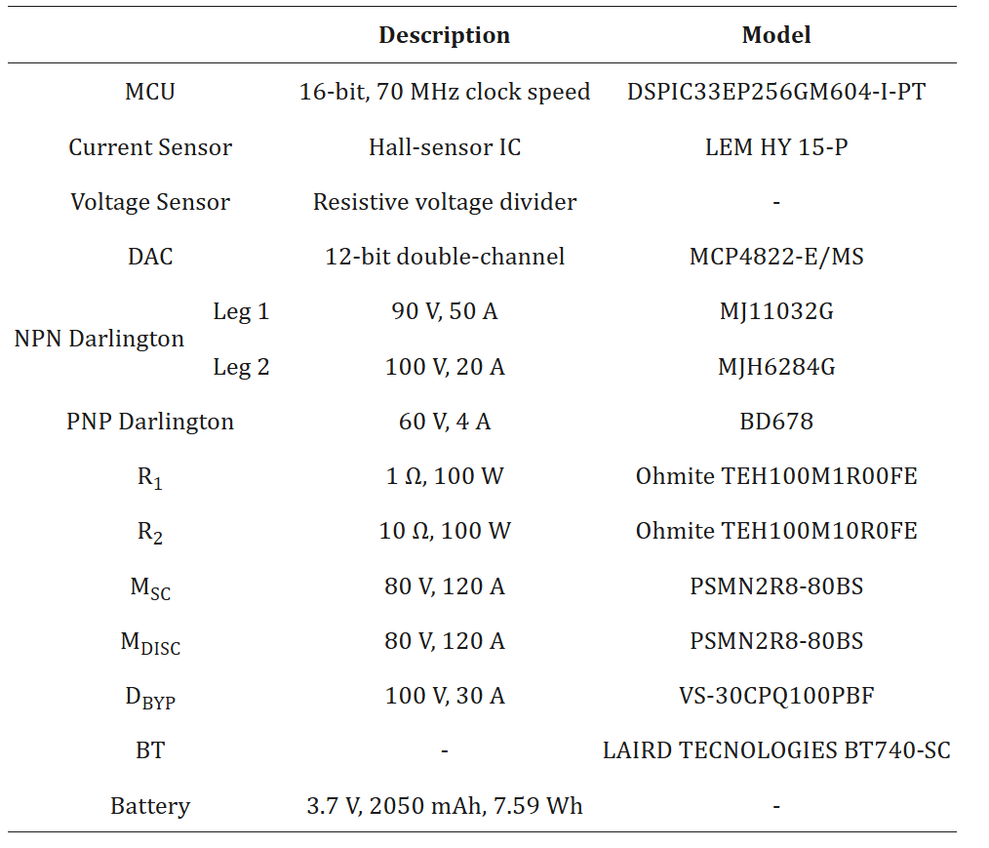

Biasing Configuration

